*Capstone Project:*

*Northwind Sales Analytics*

*_*

*Data Analytics*

*_*

*Ashutosh Choudhury*

The objective of this Project is to create a visually appealing and user-friendly dashboard that communicates key performance metrics for Northwind Traders effectively. The report aims to generate insights into customer behavior, sales patterns, and employee performance to aid decision-making processes. It will cover sales analysis, customer segmentation, inventory trends, and employee performance, consolidating data from multiple tables for a comprehensive view of the company's operations. The report will empower stakeholders to make data-driven decisions by offering valuable insights and facilitating data exploration through interactive visualizations and dynamic filters. The expected impact is to revolutionize how Northwind Traders interacts with its data, enabling the company to remain competitive and drive its business forward in the wholesale market landscape.

**OVERVIEW**

**w**

**Dataset Description**

The Northwind database contains the sales data for a fictitious company called “Northwind Traders,” which imports and exports specialty foods from around the world.

**Table Explanations**

**Customers Table:** This table stores information about the company's customers. It includes fields for customer ID, company name, contact name, contact title, address, city, region, postal code, country, phone, and fax.

**Employees Table:** This table stores information about the company's employees. It includes fields for employee ID, last name, first name, title, title of courtesy, birth date, hire date, address, city, region, postal code, country, home phone, extension, photo, notes, reports to, and photo path.

**Orders Table:** This table stores information about the company's orders. It includes fields for order ID, customer ID, employee ID, order date, required date, shipped date, ship via, freight, ship name, ship address, ship city, ship region, ship postal code, and ship country.

**Order Details Table:** This table stores detailed information about the items within each order. It includes fields for order ID, product ID, unit price, quantity, and discount.

**Products Table:** This table stores information about the company's products. It includes fields for product ID, product name, supplier ID, category ID, quantity per unit, unit price, units in stock, units on order, reorder level, and whether the product is discontinued.

**Suppliers Table:** This table stores information about the company's suppliers. It includes fields for supplier ID, company name, contact name, contact title, address, city, region, postal code, country, phone, fax, and home page.

**Shippers Table:** This table stores information about the company's shipping companies. It includes fields for shipper ID, company name, and phone.

**Categories Table:** This table stores information about the product categories. It includes fields for category ID, category name, and description.

**THE PROCESS**

__________________________________________________________________________

1. **Data Acquisition from GitHub:**

Obtain the requisite dataset from a designated GitHub Repository, containing essential information on the Northwind database encompassing various imports and exports specialty foods from around the world.

1. **Data Transformation and Enhancement:**

If necessary, execute data transformation procedures to ensure data quality and consistency. Additionally consider augmenting the dataset with new problem statements to enrich the analysis potential.

1. **Connecting with Tools:**

Establish connections between the dataset and various analytical tools. Interface the dataset with Power BI, Excel, and MySQL Workbench, facilitating seamless data integration and processing.

1. **Problem Statement Solution in Power BI:**

Utilize Power BI to delve into the specified problem statements. Employ its robust features for data visualization, exploration, and analysis, effectively deriving insights and solutions.

__________________________________________________________________________

1. **Exploratory Data Analysis (EDA):**

Perform exploratory data analysis using Excel and SQL Workbench, depending on the complexity of the analysis. Extract meaningful patterns, relationships and trends from the data to inform subsequent decision-making.

1. **Creation of Visual and Insightful PowerPoint:**

Develop a comprehensive PowerPoint presentation that encapsulates the project’s objectives, methodologies, problem statement solutions, and key visualizations. Each problem statement is accompanied by a dedicated section with pertinent conclusions and insights.

1. **Detailed Documentation:**

Compile a detailed report that meticulously documents the entire project lifecycle. Include sections on data collection, transformation, problem statement formulation, tools integration, Power BI solutions, EDA insights and PowerPoint visualizations.

__________________________________________________________________________

**OBJECTIVE**

__________________________________________________________________________

The objective of this project is to conduct a comprehensive business analysis of the **Northwind retail dataset** using structured data analytics techniques. By applying a **MECE (Mutually Exclusive, Collectively Exhaustive)** breakdown, the goal is to extract actionable insights across all major business domains including sales performance, customer behaviour, inventory management, employee productivity, and shipping logistics.

This end-to-end project demonstrates the ability to combine tools like **SQL (MySQL Workbench)** for data querying, **Microsoft Excel** for **exploratory data analysis (EDA)**, and **Power BI** for interactive dashboard reporting. Each phase of the analysis is designed to simulate real-world business intelligence tasks and to present insights that can aid in strategic decision-making.

The specific objectives are as follows:

* **Understand customer behaviour and segment them** based on total spend and order frequency.
* **Analyze sales trends and product performance** to identify top revenue drivers.
* **Evaluate inventory health and restocking needs**, including identifying discontinued or understocked products.
* **Measure employee performance and sales targets** using data-driven KPIs.
* **Assess shipping costs and delivery durations** to optimize fulfillment efficiency.

The final deliverables include an Excel-based EDA summary, five themed Power BI dashboards, a structured PowerPoint presentation, and a narrated video walkthrough that ties together the complete analysis journey.

__________________________________________________________________________

**SIGNIFICANCE**

__________________________________________________________________________

The **Northwind Retail Data Analytics project** holds significant value as it demonstrates how raw transactional data can be transformed into **meaningful business insights** using modern analytics tools. In today’s competitive business environment, organizations rely on **data-driven decision-making** to optimize operations and maintain a competitive edge.

This project highlights the **practical importance of analytics** in five critical areas:

1. **Customer-Centric Decisions:** By segmenting customers based on purchase behaviour and revenue contribution, businesses can identify high-value clients, personalize marketing strategies, and improve customer retention.
2. **Sales and Profitability Analysis:** Identifying revenue trends across time, geography, and product categories allows management to focus on high-performing areas and address underperforming segments effectively.
3. **Inventory Optimization:** Monitoring stock levels, reorder thresholds, and discontinued products ensures better supply chain planning and reduces the risk of stockouts or overstocking.
4. **Workforce Efficiency:** Evaluating employee performance through metrics like orders handled and target achievement helps improve productivity and align goals.
5. **Logistics and Cost Control:** Analyzing shipping costs and delivery times across regions supports negotiation with shippers and optimizes fulfillment strategies.

The significance of this project also lies in the **integration of multiple tools**—SQL for data extraction, Excel for EDA, and Power BI for dashboarding—to simulate a real-world **end-to-end analytics pipeline**.

Ultimately, the project demonstrates **how structured analysis and visualization techniques can convert data into actionable insights**, providing clear benefits for **business strategy, operational efficiency, and informed decision-making**.

__________________________________________________________________________

**DATA DICTIONARY**

__________________________________________________________________________

**Table: Customers**

* **Fields:**
  + CustomerID: Unique identifier for each customer.
  + CompanyName: Name of the customer’s company.
  + ContactName: Name of the primary contact person.
  + ContactTitle: Title or role of the contact person.
  + Address: Street address of the customer.
  + City: City where the customer is located.
  + Region: State/region of the customer (nullable).
  + PostalCode: Postal code for the customer’s address.
  + Country: Country of the customer.
  + Phone: Contact phone number.
  + Fax: Fax number (nullable).
  + Image: Binary data storing image (if available).
  + ImageThumbnail: Binary data storing a smaller image (thumbnail).

**Table: Orders**

* **Fields:**
  + OrderID: Unique identifier for each order.
  + CustomerID: Foreign key referencing the Customers table.
  + EmployeeID: Foreign key referencing the Employees table.
  + OrderDate: Date when the order was placed.
  + RequiredDate: Date by which the customer expects the order.
  + ShippedDate: Date the order was shipped.
  + ShipVia: Foreign key referencing the Shippers table.
  + Freight: Cost of freight/shipping.
  + ShipName: Name of the shipper/consignee.
  + ShipAddress: Shipping Street address.
  + ShipCity: City for delivery.
  + ShipRegion: Region for delivery.
  + ShipPostalCode: Postal code for delivery.
  + ShipCountry: Country of delivery.

**Table: Order Details**

* **Fields:**
  + OrderID: Foreign key referencing Orders table.
  + ProductID: Foreign key referencing Products table.
  + UnitPrice: Price per unit of the product at the time of order.
  + Quantity: Number of units ordered.
  + Discount: Discount applied (e.g., 0.15 = 15%).

**Table: Products**

* **Fields:**
  + ProductID: Unique identifier for each product.
  + ProductName: Name of the product.
  + SupplierID: Foreign key referencing Suppliers table.
  + CategoryID: Foreign key referencing Categories table.
  + QuantityPerUnit: Description of package size or quantity.
  + UnitPrice: Price per unit.
  + UnitsInStock: Current inventory in stock.
  + UnitsOnOrder: Units ordered but not yet received.
  + ReorderLevel: Inventory level at which reordering is triggered.
  + Discontinued: Indicates if the product is discontinued (1 = yes, 0 = no).

**Table: Suppliers**

* **Fields:**
  + SupplierID: Unique identifier for each supplier.
  + CompanyName: Name of the supplier’s company.
  + ContactName: Name of the contact person.
  + ContactTitle: Title of the contact person.
  + Address: Street address of the supplier.
  + City: City where the supplier is located.
  + Region: State or region of the supplier (nullable).
  + PostalCode: Postal code.
  + Country: Country of the supplier.
  + Phone: Contact phone number.
  + Fax: Fax number (nullable).
  + HomePage: Supplier’s website or homepage (nullable).

**Table: Categories**

* **Fields:**
  + CategoryID: Unique identifier for each product category.
  + CategoryName: Name of the category (e.g., Beverages, Confections).
  + Description: Brief description of the category.
  + Picture: Binary data for the category picture.

**Table: Shippers**

* **Fields:**
  + ShipperID: Unique identifier for each shipping company.
  + CompanyName: Name of the shipping company.
  + Phone: Contact phone number of the shipper.

**Table: Employees**

* **Fields:**
  + EmployeeID: Unique identifier for each employee.
  + LastName: Employee’s last name.
  + FirstName: Employee’s first name.
  + Title: Job title of the employee.
  + TitleOfCourtesy: Courtesy title (Mr., Ms., Dr.).
  + BirthDate: Employee’s date of birth.
  + HireDate: Date when the employee was hired.
  + Address: Street address.
  + City: City where the employee lives.
  + Region: State/region.
  + PostalCode: Postal code.
  + Country: Country.
  + HomePhone: Employee’s phone number.
  + Extension: Phone extension.
  + Photo: Binary data for employee photo.
  + Notes: Additional notes about the employee.
  + ReportsTo: Manager’s EmployeeID (nullable).

__________________________________________________________________________

**ER DIAGRAM**

__________________________________________________________________________

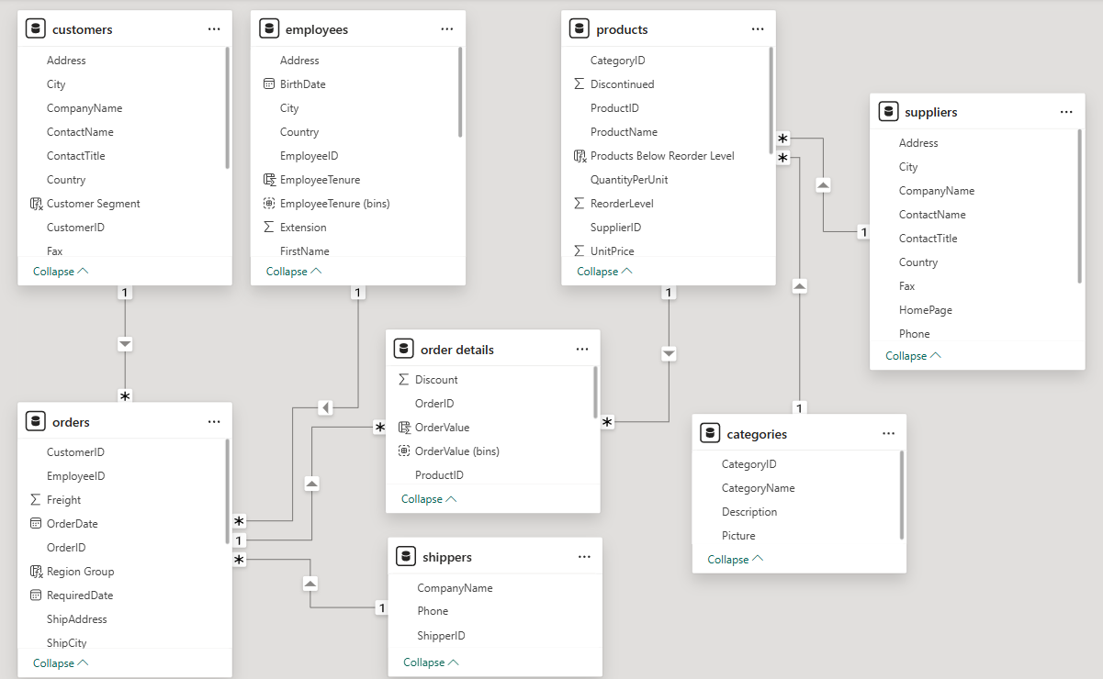

The ER diagram shown above represents the **data model created in Power BI** using the Northwind dataset.

It defines the **relationships between key business entities**, such as:

* **Customers, Orders, and Order Details** (linking customer purchases to specific items)
* **Products, Categories, and Suppliers** (capturing product information and supply chain)
* **Shippers and Employees** (managing logistics and sales responsibilities)

These relationships form the backbone of the data model and enable the creation of dynamic, cross-functional dashboards.

The model ensures **referential integrity** and supports **drill-through analysis across different business dimensions**.

__________________________________________________________________________

**MECE BREAKDOWN**

__________________________________________________________________________

The project was divided into five distinct analytical areas:

**I. Sales Analysis Dashboard (Revenue & Performance Monitoring)**

| **KPI/Analysis** | **Purpose** |
| --- | --- |
| **Total Sales** | Monitor overall sales performance |
| **Total Orders** | Track order volume |
| **Average Order Value** | Understand per-order revenue |
| **Sales Trend by Year & Month** | Identify seasonality and trends |
| **Sales by Product Category** | Highlight top-performing categories |

**II. Customer Segmentation Dashboard (Customer Profiling & Value Analysis)**

| **Analysis** | **Purpose** |
| --- | --- |
| **Customer Table (Details)** | Identify top and low-performing customers |
| **Orders by Country** | Understand geographic customer distribution |
| **Customer Segmentation (High/Medium/Low/No Orders)** | Classify customers based on their sales contribution |

**III. Inventory Analysis Dashboard (Stock & Supply Monitoring)**

| **Analysis** | **Purpose** |
| --- | --- |
| **Units in Stock by Category** | Visualize current inventory health |
| **Active vs Discontinued Products** | Track product lifecycle status |
| **Inventory Table (Stock, Order, Reorder Info)** | Operational view of product availability |
| **Gauge for Products Below Reorder Level** | Monitor restocking risk with a defined threshold |

**IV. Employee Performance Dashboard (Sales & Operational Efficiency)**

| **Analysis** | **Purpose** |
| --- | --- |
| **Orders Handled by Employee** | Evaluate employee workload distribution |
| **Total Sales vs Sales Target** | Monitor goal achievement per employee/team |
| **Sales Trend by Employee** | Track performance over time |
| **Country Slicer (US, UK, etc.)** | Filter team performance by region |

**V. Shipping & Order Fulfillment Dashboard (Logistics & Delivery Efficiency)**

| **Analysis** | **Purpose** |
| --- | --- |
| **Freight Cost by Country** | Monitor shipping costs geographically |
| **Average Shipping Duration by Company** | Track fulfillment speed by customer |
| **Average Freight by Region Group** | Identify cost patterns in North America, Europe, South America, Other |

__________________________________________________________________________

**POWER BI DASHBOARDS**

__________________________________________________________________________

Five dashboards were created in Power BI for different analytical tracks:

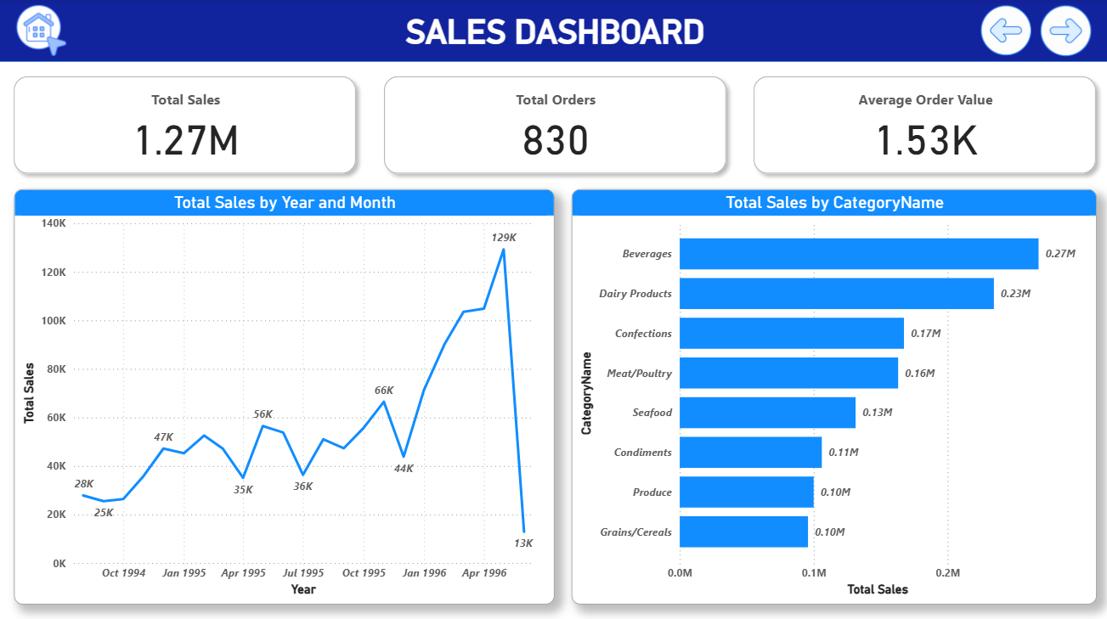  
***1. Sales Dashboard:***KPIs (Total Sales, Orders, AOV), Sales by Year, Month, and Category

* **KPIs – Total Sales, Total Orders, Average Order Value**

**Problem Statement:**  
*What are the key metrics that summarize overall sales performance?*

**Analysis:**  
The KPI cards provide a snapshot of the business performance at a glance.

* **Total Sales:** Shows the overall revenue generated during the analysis period.
* **Total Orders:** Reflects the volume of transactions handled.
* **Average Order Value (AOV):** Indicates how much revenue is generated per order on average.

These KPIs help management quickly gauge the **scale of business operations and the efficiency of sales**.

* **Total Sales by Year and Month**

**Problem Statement:**  
*How has sales performance changed over time?*

**Analysis:**  
The **line chart of sales by year and month** show clear seasonality and growth trends.

* Peaks in certain months highlight **periods of high customer demand**.
* The year-on-year growth pattern provides insights into **long-term business expansion**.

This trend analysis supports **strategic planning, inventory stocking, and forecasting**.

* **Total Sales by Category Name**

**Problem Statement:**  
*Which product categories contribute the most to total revenue?*

**Analysis:**  
The **category-wise sales analysis** reveals that certain categories (such as Beverages, Dairy Products, and Confections) are **major revenue drivers**.  
This allows the company to focus marketing, procurement, and pricing strategies on **high-performing categories** while identifying underperforming areas for improvement.

__________________________________________________________________________

__________________________________________________________________________

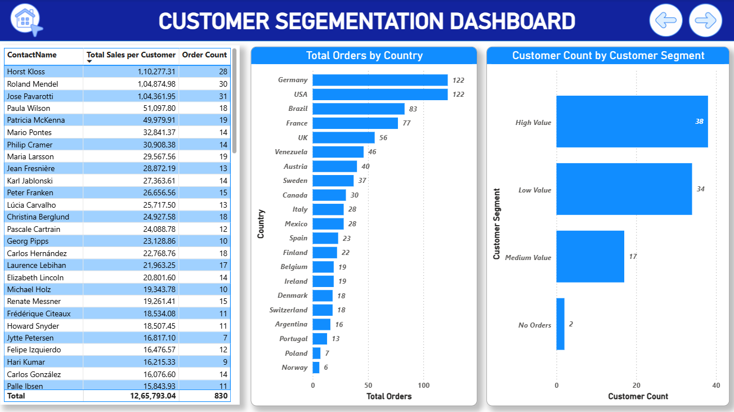***2. Customer Segmentation:*** Customer Table, Country-wise orders, Customer Count by Customer Segment

* + - **Customer Table – Contact Name, Total Sales, and Order Count**

**Problem Statement:**  
*Who are our key customers and what is their contribution to sales and orders?*

**Analysis:**  
The customer table displays detailed metrics for each customer, including **Contact Name, Total Sales, and Order Count**.  
This view helps to **identify high-value customers**, monitor their purchase frequency, and understand **who drives the majority of revenue**.  
It is essential for **relationship management and personalized marketing efforts**.

* + - **Country-wise Orders**

**Problem Statement:**  
*How are orders distributed geographically?*

**Analysis:**  
The **bar chart of orders by country** highlights which regions place the most orders.  
Countries like the **USA and Germany show the highest order volumes**, while smaller markets contribute fewer orders.  
This geographic analysis allows **targeted campaigns and logistics planning** based on regional demand.

* + - **Customer Count by Customer Segment**

**Problem Statement:**  
*How many customers fall into high, medium, low, and no-order segments?*

**Analysis:**  
The segmentation visualization categorizes customers into **High Value, Medium Value, Low Value, and No Orders** groups based on their purchase history.

* **High-value customers** are a small but significant portion contributing most to sales.
* **Low-value or inactive customers** present opportunities for **re-engagement campaigns**.

This segmentation helps **prioritize customer retention strategies and tailor marketing efforts**.

**Insert screenshot of customer segment chart here.**

__________________________________________________________________________

__________________________________________________________________________

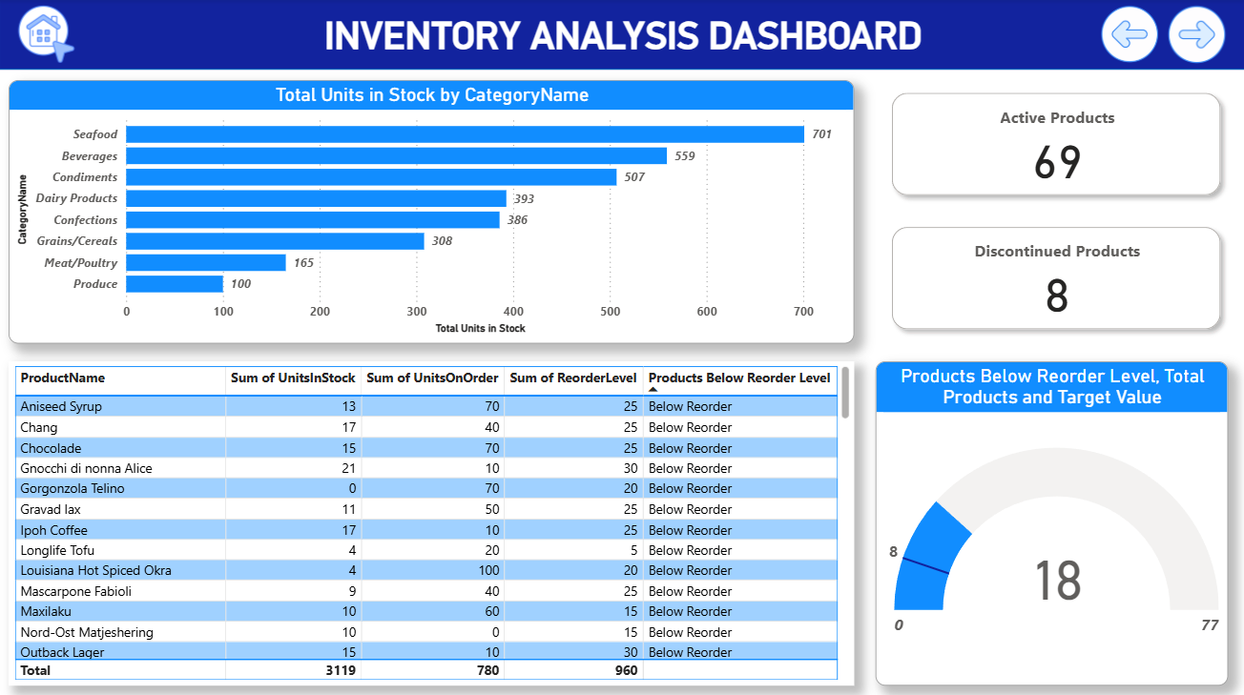***3. Inventory Analysis:*** Total units in stock, Products below reorder level, stock trends, active & discontinued products

* + - **Total Units in Stock by Category**

**Problem Statement:**  
*How are the current stock levels distributed across product categories?*

**Analysis:**  
The bar chart showing **total units in stock by category** gives an overview of which product categories hold the largest inventory.  
This helps in understanding **stock allocation** and ensures resources are directed to **manage high-volume categories efficiently**.

* + - **Products Below Reorder Level**

**Problem Statement:**  
*Which products are running low and need to be reordered?*

**Analysis:**  
A **gauge visual and table** highlight products whose stock levels have dropped **below the reorder threshold**.  
This allows timely **reordering decisions**, preventing stockouts and ensuring smooth supply chain operations.

* + - **Stock Trends**

**Problem Statement:**  
*How are stock quantities and orders aligned?*

**Analysis:**  
A table visualization combining **Units in Stock, Units on Order, and Reorder Levels** provides insights into **future stock availability**.  
This helps in balancing **current inventory with expected replenishments**.

* + - **Active vs Discontinued Products**

**Problem Statement:**  
*How many products are active versus discontinued?*

**Analysis:**  
A simple **card/indicator visual** displays the count of **active products and discontinued products**.  
This helps to **track product lifecycle** and supports decisions regarding replacements or phase-outs.

__________________________________________________________________________

__________________________________________________________________________

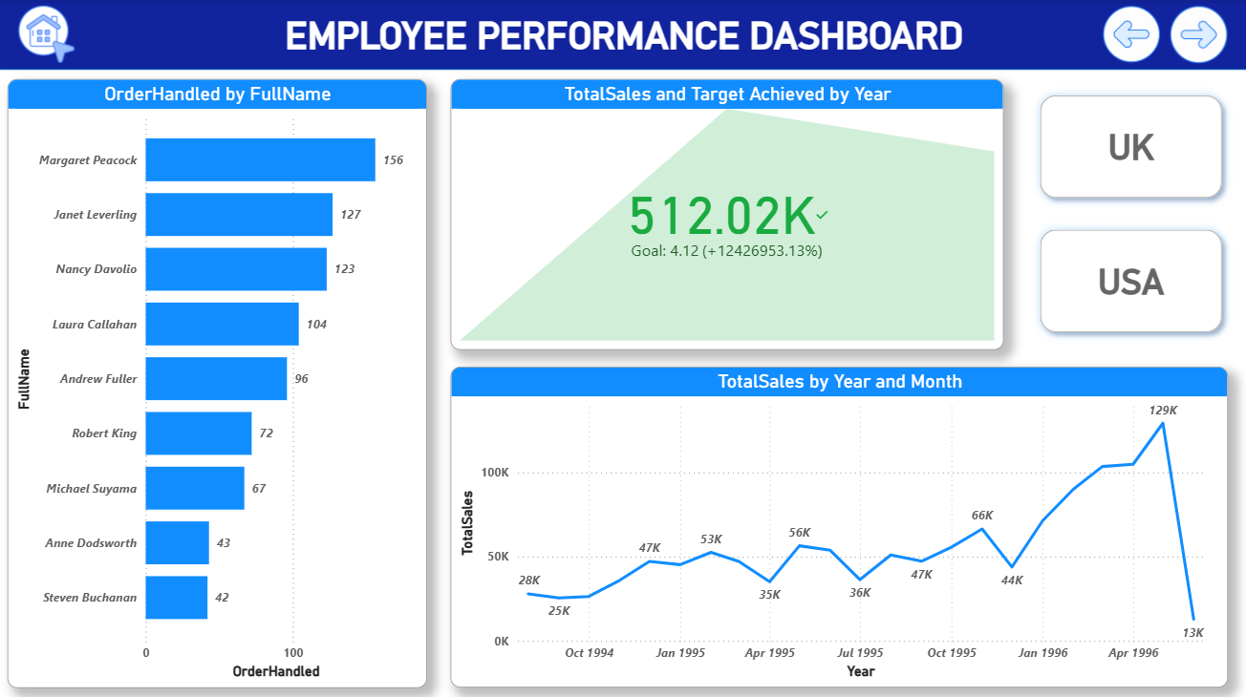***4. Employee Performance:*** Orders handled by employee, sales vs target, regional performance

* + - **Orders Handled by Employee**

**Problem Statement:**  
*Which employees handle the most orders?*

**Analysis:**  
The **bar chart of orders handled by each employee** highlights workload distribution across the sales team.  
It helps identify **top-performing employees**, understand workload balance, and detect areas where additional support or training may be required.

* + - **Sales vs Target**

**Problem Statement:**  
*Are employees meeting their sales targets?*

**Analysis:**  
The **KPI visual (Sales vs Target)** compares actual sales achieved against predefined goals.  
This enables tracking of **goal completion percentages**, showing who is exceeding targets and who may need additional guidance to meet objectives.

* + - **Regional Performance**

**Problem Statement:**  
*How does employee performance vary by region?*

**Analysis:**  
A **slicer and related visuals** enable filtering employee data by region (e.g., US, UK).  
This reveals **regional patterns in sales and order handling**, helping managers align resources and **set realistic targets** based on market performance.

__________________________________________________________________________

__________________________________________________________________________

***5. Shipping & Fulfillment:*** Freight costs, shipping durations, grouped regional analysis

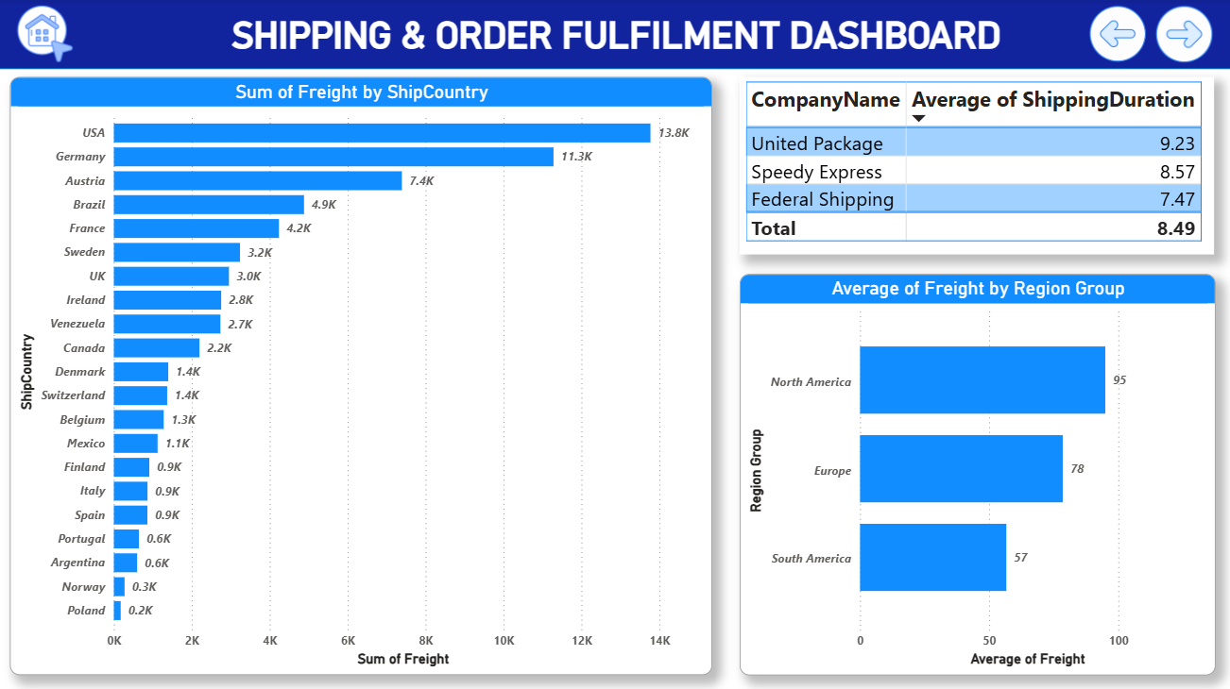

* + - **Freight Costs by Country**

**Problem Statement:**  
*Which countries incur the highest freight costs?*

**Analysis:**  
The **bar chart of freight costs by country** shows how shipping expenses vary geographically.  
This helps identify **cost-heavy regions**, enabling the business to explore ways to **optimize shipping methods or negotiate better rates with carriers**.

* + - **Shipping Duration by Company**

**Problem Statement:**  
*Which shipping providers deliver the fastest?*

**Analysis:**  
A **table visual** displays the **average shipping duration for each shipping company**.  
This analysis helps measure **efficiency and reliability** of shippers, making it easier to select the best partners for future shipments.

* + - **Grouped Regional Freight Analysis**

**Problem Statement:**  
*How do freight costs compare across regional groups?*

**Analysis:**  
A **bar chart grouped by regions (North America, Europe, South America, Other)** shows how average freight charges vary by region.  
This high-level view helps identify **regional cost patterns** and supports strategic decisions regarding **shipping policies and cost control**.

__________________________________________________________________________

**EXCEL & SQL BASED EDA**

__________________________________________________________________________

SQL queries were used to extract and summarize customer patterns, order behaviours, product demand, and supplier details. Results were pasted into Excel for formatting, charting, and insight writing.

**Exploratory Data Analysis (EDA)** was conducted using SQL queries on the Northwind database.  
This step helped to **understand the data structure, identify patterns, and generate insights** that form the basis for the Power BI dashboards created later.  
The analysis focused on customer behaviour, sales performance, product contributions, and shipping trends.  
Below are some of the key EDA findings.

***Selected EDA Questions***

**Problem Statement:**

*What is the average number of orders per customer?*

**Analysis:**  
High-value repeat customers such as QUICK-Stop and Ernst Handel generate significant revenue with frequent orders. This insight helps identify **loyal and high-impact customers**.

**Result:**

|  |
| --- |
| **AvgOrderPerCustomer** |
| 9.3258 |

**Problem Statement:**

*How do customer order patterns vary by city or country?*

**Analysis:**  
Order behaviour differs by region. Cities like Cunewalde (Germany) and Boise (USA) show **higher revenue per order**, while cities like London (UK) generate **more frequent but lower-value orders**.

**Result:**

|  |  |  |  |  |
| --- | --- | --- | --- | --- |
| **City** | **Country** | **TotalOrders** | **TotalRevenue** | **AvgOrderValue** |
| Cunewalde | Germany | 28 | 110277.3 | 3938.48 |
| Graz | Austria | 30 | 104874.98 | 3495.83 |
| Boise | USA | 31 | 104361.95 | 3366.51 |
| London | UK | 46 | 52825.01 | 1148.37 |
| Rio de Janeiro | Brazil | 34 | 51956.98 | 1528.15 |
| Albuquerque | USA | 18 | 51097.8 | 2838.77 |
| Cork | Ireland | 19 | 49979.9 | 2630.52 |
| São Paulo | Brazil | 31 | 40486.46 | 1306.01 |
| Brandenburg | Germany | 14 | 30908.38 | 2207.74 |
| Bräcke | Sweden | 19 | 29567.56 | 1556.19 |
| Montréal | Canada | 13 | 28872.19 | 2220.94 |
| Seattle | USA | 14 | 27363.6 | 1954.54 |
| München | Germany | 15 | 26656.56 | 1777.1 |
| Luleå | Sweden | 18 | 24927.58 | 1384.87 |
| Charleroi | Belgium | 12 | 24088.78 | 2007.4 |
| México D.F. | Mexico | 28 | 23582.08 | 842.22 |
| Salzburg | Austria | 10 | 23128.86 | 2312.89 |
| San Cristóbal | Venezuela | 18 | 22768.76 | 1264.93 |
| Marseille | France | 17 | 21963.25 | 1291.96 |
| Tsawassen | Canada | 14 | 20801.6 | 1485.83 |
| Genève | Switzerland | 10 | 19343.78 | 1934.38 |
| Frankfurt a.M. | Germany | 15 | 19261.41 | 1284.09 |
| Strasbourg | France | 11 | 18534.08 | 1684.92 |
| Eugene | USA | 11 | 18507.45 | 1682.5 |
| København | Denmark | 7 | 16817.1 | 2402.44 |
| I. de Margarita | Venezuela | 12 | 16476.56 | 1373.05 |
| Barquisimeto | Venezuela | 14 | 16076.6 | 1148.33 |
| Århus | Denmark | 11 | 15843.92 | 1440.36 |
| Oulu | Finland | 15 | 15648.7 | 1043.25 |
| Anchorage | USA | 10 | 15177.46 | 1517.75 |
| Köln | Germany | 10 | 12496.2 | 1249.62 |
| Bern | Switzerland | 8 | 12348.88 | 1543.61 |
| Lille | France | 5 | 11666.9 | 2333.38 |
| Lisboa | Portugal | 13 | 11472.36 | 882.49 |
| Sevilla | Spain | 10 | 11446.36 | 1144.64 |
| Lander | USA | 9 | 11441.63 | 1271.29 |
| Bruxelles | Belgium | 7 | 9736.07 | 1390.87 |
| Stuttgart | Germany | 10 | 9588.42 | 958.84 |
| Toulouse | France | 14 | 9328.2 | 666.3 |
| Lyon | France | 10 | 9182.43 | 918.24 |
| Campinas | Brazil | 9 | 8414.13 | 934.9 |
| Buenos Aires | Argentina | 16 | 8119.1 | 507.44 |
| Portland | USA | 12 | 7619.6 | 634.97 |
| Bergamo | Italy | 10 | 7176.21 | 717.62 |
| Reggio Emilia | Italy | 12 | 7048.24 | 587.35 |
| Cowes | UK | 10 | 6146.3 | 614.63 |
| Resende | Brazil | 9 | 6068.2 | 674.24 |
| Stavern | Norway | 6 | 5735.15 | 955.86 |
| Madrid | Spain | 8 | 5700.14 | 712.52 |
| Leipzig | Germany | 5 | 5042.2 | 1008.44 |
| Nantes | France | 7 | 4788.06 | 684.01 |
| Münster | Germany | 6 | 4778.14 | 796.36 |
| Berlin | Germany | 6 | 4273 | 712.17 |
| Aachen | Germany | 6 | 3763.21 | 627.2 |
| Warszawa | Poland | 7 | 3531.95 | 504.56 |
| Mannheim | Germany | 7 | 3239.8 | 462.83 |
| Helsinki | Finland | 7 | 3161.35 | 451.62 |
| San Francisco | USA | 4 | 3076.47 | 769.12 |
| Elgin | USA | 5 | 3063.2 | 612.64 |
| Paris | France | 4 | 2423.35 | 605.84 |
| Versailles | France | 4 | 1992.05 | 498.01 |
| Butte | USA | 3 | 1947.24 | 649.08 |
| Kirkland | USA | 3 | 1571.2 | 523.73 |
| Torino | Italy | 6 | 1545.7 | 257.62 |
| Caracas | Venezuela | 2 | 1488.7 | 744.35 |
| Reims | France | 5 | 1480 | 296 |
| Barcelona | Spain | 5 | 836.7 | 167.34 |
| Vancouver | Canada | 3 | 522.5 | 174.17 |
| Walla Walla | USA | 2 | 357 | 178.5 |

**Problem Statement:**

*Which product categories and products contribute most to revenue?*

**Analysis:**  
The top three revenue-generating products—Côte de Blaye, Thüringer Rostbratwurst, and Raclette Courdavault—account for a **large portion of total revenue**. These findings inform **inventory and category planning**.

**Result:**

|  |  |  |
| --- | --- | --- |
| **ProductID** | **ProductName** | **TotalRevenue** |
| 38 | Côte de Blaye | 141396.73 |
| 29 | Thüringer Rostbratwurst | 80368.67 |
| 59 | Raclette Courdavault | 71155.7 |
| 62 | Tarte au sucre | 47234.97 |
| 60 | Camembert Pierrot | 46825.48 |
| 56 | Gnocchi di nonna Alice | 42593.06 |
| 51 | Manjimup Dried Apples | 41819.65 |
| 17 | Alice Mutton | 32698.38 |
| 18 | Carnarvon Tigers | 29171.87 |
| 28 | Rössle Sauerkraut | 25696.64 |

**Problem Statement:**

*How frequently do different customer segments place orders?*

**Analysis:**  
High-value segments average nearly **14 orders per customer**, while low-value segments average fewer than 5. This justifies **segmentation strategies and targeted marketing**.

**Result:**

|  |  |  |  |
| --- | --- | --- | --- |
| **SpendSegment** | **NumCustomers** | **TotalOrders** | **AvgOrdersPerCustomer** |
| High-Value | 38 | 526 | 13.84 |
| Mid-Value | 17 | 147 | 8.65 |
| Low-Value | 34 | 157 | 4.62 |

**Problem Statement:**

*Are there any regional trends in supplier distribution and pricing?*

**Analysis:**  
Supplier analysis shows that **France and Germany dominate in terms of supplier count and higher-priced products**, while countries like Brazil and Denmark supply **lower-priced categories**. These insights help in **strategic sourcing decisions**.

**Result:**

|  |  |  |
| --- | --- | --- |
| **Country** | **NumSuppliers** | **AvgProductPrice** |
| France | 3 | 76.75 |
| Germany | 3 | 37.6 |
| Australia | 2 | 33.83 |
| Japan | 2 | 30.46 |
| Spain | 1 | 29.5 |
| Italy | 2 | 27.36 |
| Canada | 2 | 27.31 |
| Singapore | 1 | 26.48 |
| UK | 2 | 22.81 |
| USA | 4 | 20.87 |
| Norway | 1 | 20 |
| Finland | 1 | 18.08 |
| Sweden | 2 | 18 |
| Netherlands | 1 | 11.13 |
| Denmark | 1 | 10.75 |
| Brazil | 1 | 4.5 |

These EDA findings **laid the groundwork for the dashboard design**.  
Patterns identified here directly influenced the focus of the dashboards: **Sales trends, Customer segmentation, Inventory management, Employee performance, and Shipping efficiency.**

__________________________________________________________________________

**KEY INSIGHTS**

__________________________________________________________________________

The analysis of the Northwind dataset using **SQL, Excel, and Power BI** provided several actionable insights across customers, sales, inventory, employees, and suppliers:

**Customer Insights**

* A small group of **high-value repeat customers** contributes disproportionately to total revenue.
* **Geographic trends** show that the USA and Germany generate the highest order volumes, with cities like Cunewalde and Boise having high-value orders.
* **Customer segmentation** revealed that high-value customers place 3x more orders compared to low-value customers.

**Sales & Product Insights**

* **Beverages, Dairy Products, and Confections** are the top-performing product categories.
* A few premium products such as **Côte de Blaye and Thüringer Rostbratwurst** account for a large share of revenue.
* Monthly trend analysis indicates **peak sales periods**, which can guide inventory and promotional planning.

**Inventory Insights**

* Several products are **below reorder level**, indicating a need for proactive restocking.
* The count of **discontinued products** suggests opportunities to introduce new items to fill gaps.

**Employee Performance**

* Orders are unevenly distributed across employees, with a few handling significantly more workload.
* KPI tracking shows clear **overperformance by some employees and underperformance by others**, helping target training and support.

**Supplier & Shipping Insights**

* **France and Germany dominate supplier distribution**, often offering higher-priced products.
* **Freight costs vary by country and region**, with Europe incurring higher costs than North America.
* **Federal Shipping offers the fastest delivery**, while United Package has the longest average shipping time.

**Overall Impact:**

These findings highlight opportunities for **customer relationship management, inventory planning, targeted marketing, supplier negotiation, and performance monitoring**, all of which can lead to **data-driven decision-making and improved operational efficiency**.

__________________________________________________________________________

**CONCLUSION**

__________________________________________________________________________

This project demonstrates how **data-driven insights can transform raw business data into actionable strategies**.  
By applying a structured **MECE-based approach**, the Northwind dataset was analyzed through **SQL for data extraction, Excel for exploratory analysis, and Power BI for interactive dashboards**.

The findings highlighted **key customer segments, sales trends, product performance, inventory gaps, employee efficiency, and supplier/shipping patterns**. These insights provide a strong foundation for **strategic decision-making, operational improvements, and targeted business initiatives**.

Through this project, I have strengthened my skills in:

* **Data modeling and SQL querying**
* **Exploratory Data Analysis (EDA)**
* **Interactive dashboard design and storytelling with Power BI**

In conclusion, the Northwind Analytics project showcases the **value of integrating analytics tools and structured thinking to derive clear, actionable outcomes from complex business data**.

__________________________________________________________________________



***Thank You***